Case Study – Just In Time Toyota
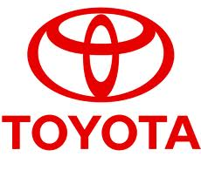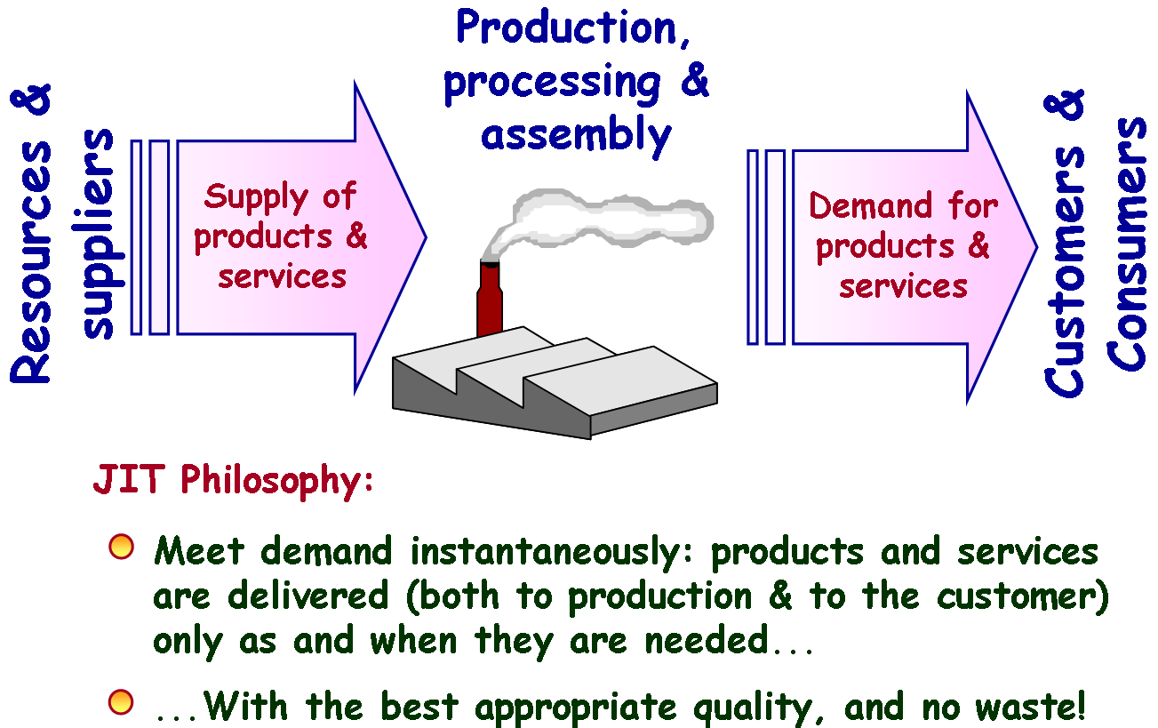
First, of course, it taught the modern car industry how to make cars properly. Few had heard of the Toyota Production System (TPS) until three academics in the car industry study programme run by Massachusetts Institute of Technology (MIT) wrote a book in 1991 called “The Machine that Changed the World”. It described the principles and practices behind the “just-in-time”manufacturing system developed at Toyota by Taiichi Ohno. He in turn had drawn inspiration from W. Edwards Deming, an influential statistician and quality-control expert who had played a big part in developing the rapid-manufacturing processes used by America during the Second World War. At the core of TPS is elimination of waste and absolute concentration on consistent high quality by a process of continuous improvement (kaizen). The catchy just-in time aspect of bringing parts together just as they are needed on the line is only the clearest manifestation of the relentless drive to eliminate mud waste) from the manufacturing process. The world's motor industry, and many other branches of manufacturing, rushed to embrace and adopt the principles of TPS. Toyota's success starts with its brilliant production engineering, which puts quality control in the hands of the line workers who have the power to stop the line or summon help the moment something goes wrong. Walk into a Toyota factory in Japan or America, Derby in Britain or Valentines in France and you will see the same visual displays telling you everything that is going on. You will also hear the same jingles at the various work stations telling you a model is being changed, an operation have been completed or a brief halt called. Everything is minutely synchronized; the work goes at the same steady cadence of one car a minute rolling off the final assembly line. Each operation along the way takes that time. No one ushers and there are cute slings and swiveling loaders to take the heavy lifting out of the work. But there is much more to the soul of the Toyota machine than a dour, relentless pursuit of perfection in its car factories. Another triumph is the slick product-development process that can roll out new modelsin barely two years. As rival Carlos Ghosn, chief executive of Nissan, notes in his book “Shift”(about how he turned around the weakest of Japan's big three), as soon as Toyota bosses spot a gap in the market or a smart new product from a rival, they swiftly move in with their own version.
Many firms have tried to install the Toyota Production system TPS. They set up the Kanban system, which is a tool for managing the flow and production of materials in a Toyota-style“pull” production system. They plug in the and on, which is a visual control device in a production area that alerts workers to defects, equipment abnormalities or other problems using signals such as lights, audible alarms, etc. Finally, with all these devices the workplace looks like a Toyota plant. Yet over time the workplace reverts to operating like it did before. And this is exactly what many Western organizations have experienced. With the set up of TPS, the real work of implementing TPS has just begun. In the Toyota Way, it’s the people who bring the system to life by working, communicating, resolving issues and growing together. The Toyota Way encourages, supports and in fact demands employee involvement. The Toyota Way is much more than a set of improvement and efficiency techniques. It’s a culture depending on worker attitude to reduce inventory, identify hidden problems and to fix them with a sense of urgency, purpose and team work. The Toyota Production System can be copied, the Toyota Way cannot. It has to be built, maintained and refined over decades.
Methods Used In Controlling Waste
The purpose of TPS is to minimize time spent on non-value adding activities by positioning the materials and tools as close as possible to the point of assembly. The major types of non-value adding waste in business or production process are overproduction, waiting or time on hand, unnecessary transport or conveyance, over processing or incorrect processing, excess inventory, unnecessary movement, defects and unused employee creativity. The driving force behind the Japanese system of production is eliminating waste, thereby maximizing process efficiency andthe returns on resources. A wide number of principles and practices can be employed to achieve this goal. As Shingo once noted, people instinctively know to eliminate waste once it is identified as such, so the task of reducing waste often centers first around identifying unnecessary uses of human, capital, or physical resources. After waste is targeted, new processes or practices can be devised to deal with it.

Just-In-Time (Jit)
Just-in-time (JIT) production. The pioneers of these methods were Taiichi Ohno, a former Toyota executive, and Shigeo Shingo, an eminent engineer and consultant. In his 1989 book The Study of the Toyota Production System from an Industrial Engineering Perspective, Shingo identified these basic features of TPS:
1. It achieves cost reductions by eliminating waste, be it staff time, materials, or other resources.
2. It reduces the likelihood of overproduction by maintaining low inventories ("nonstock")and keeps labor costs low by using minimal manpower.
3. It reduces production cycle time drastically with innovations like the Single-MinuteExchange of Die (SMED) system, which cuts downtime and enables small-lot production.
4. It emphasizes that product orders should guide production decisions and processes, a practice known as order-based production.

Process Improvement
An important aspect of eliminating waste is designing efficiency into production processes andmethods. For example, in the Toyota system heavy emphasis was placed on lowering the timeand complexity required to change a die in a manufacturing process. A time-consuming die-changing process is wasteful in two ways. First, while it is happening production is often at astandstill, increasing cycle times and all the costs associated with longer cycle times. (However,it is important to note that idle time for individual machines in a system is not always viewed aswasteful under the TPS philosophy.) Second, workers' time and effort are spent on activities thataren't directly related to production (i.e., no value is being added by changing a die). As a resultof such concerns, the push at Toyota was to reduce significantly the time it took to change dies.
VALUE ADDED
TPS and similar Japanese manufacturing techniques distinguish between activities that add valueto a product and those that are logistical but add no value. The primary—even the sole—value-added activity in manufacturing is the production process itself, where materials are beingtransformed into progressively functional work pieces. Most other activities, such as transportingmaterials, inspecting finished work, and most of all, idle time and delays, add no value and must be minimized. When processes are examined for potential improvements and cost cutting,reducing non-value-added activities is often the highest priority. Conversely, processes that addthe most value, even if they are expensive, will usually not be compromised to achieve lower costs at the expense of quality.

